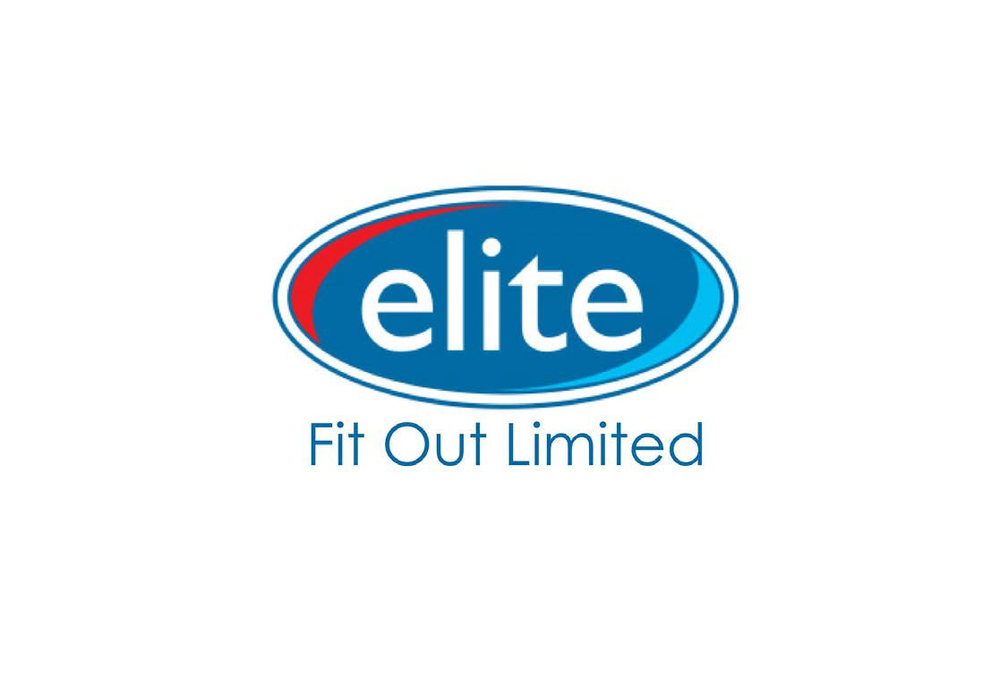

Elite Fit Out Limited
Unit B17 Valley Business Centre
Newtownabbey
BT36 7LS

02890 864 133 info@eliteni.com

www.eliteni.com

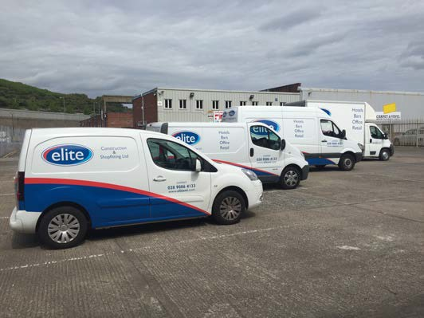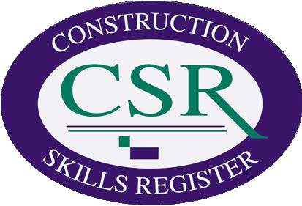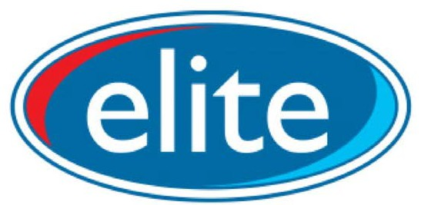

Elite Fit Out

Elite Fit Out can provide its customers with all the needs of the modern construction industry. From Shopfitting and manufacturing, General Construction in terms of building works, through to response and property maintenance needs covering your property and your investment 24/7. Working with respected clients whom avail of our maintance response service to ensure they are covered at all times.

What We Offer

We offer a wide array of service to suit our clients and customers:

v Fit Out/Manufacturing
v Construction
v 24/7 Response Maintenance
v Property Maintenance & Management

By offering all these services we have many happy returning customers whom constantly come back to use us time and time again, knowing that we adapt to the ever evolving construction industry, and know that we offer a quality professional service tailored to suit their needs.

www.eliteni.com

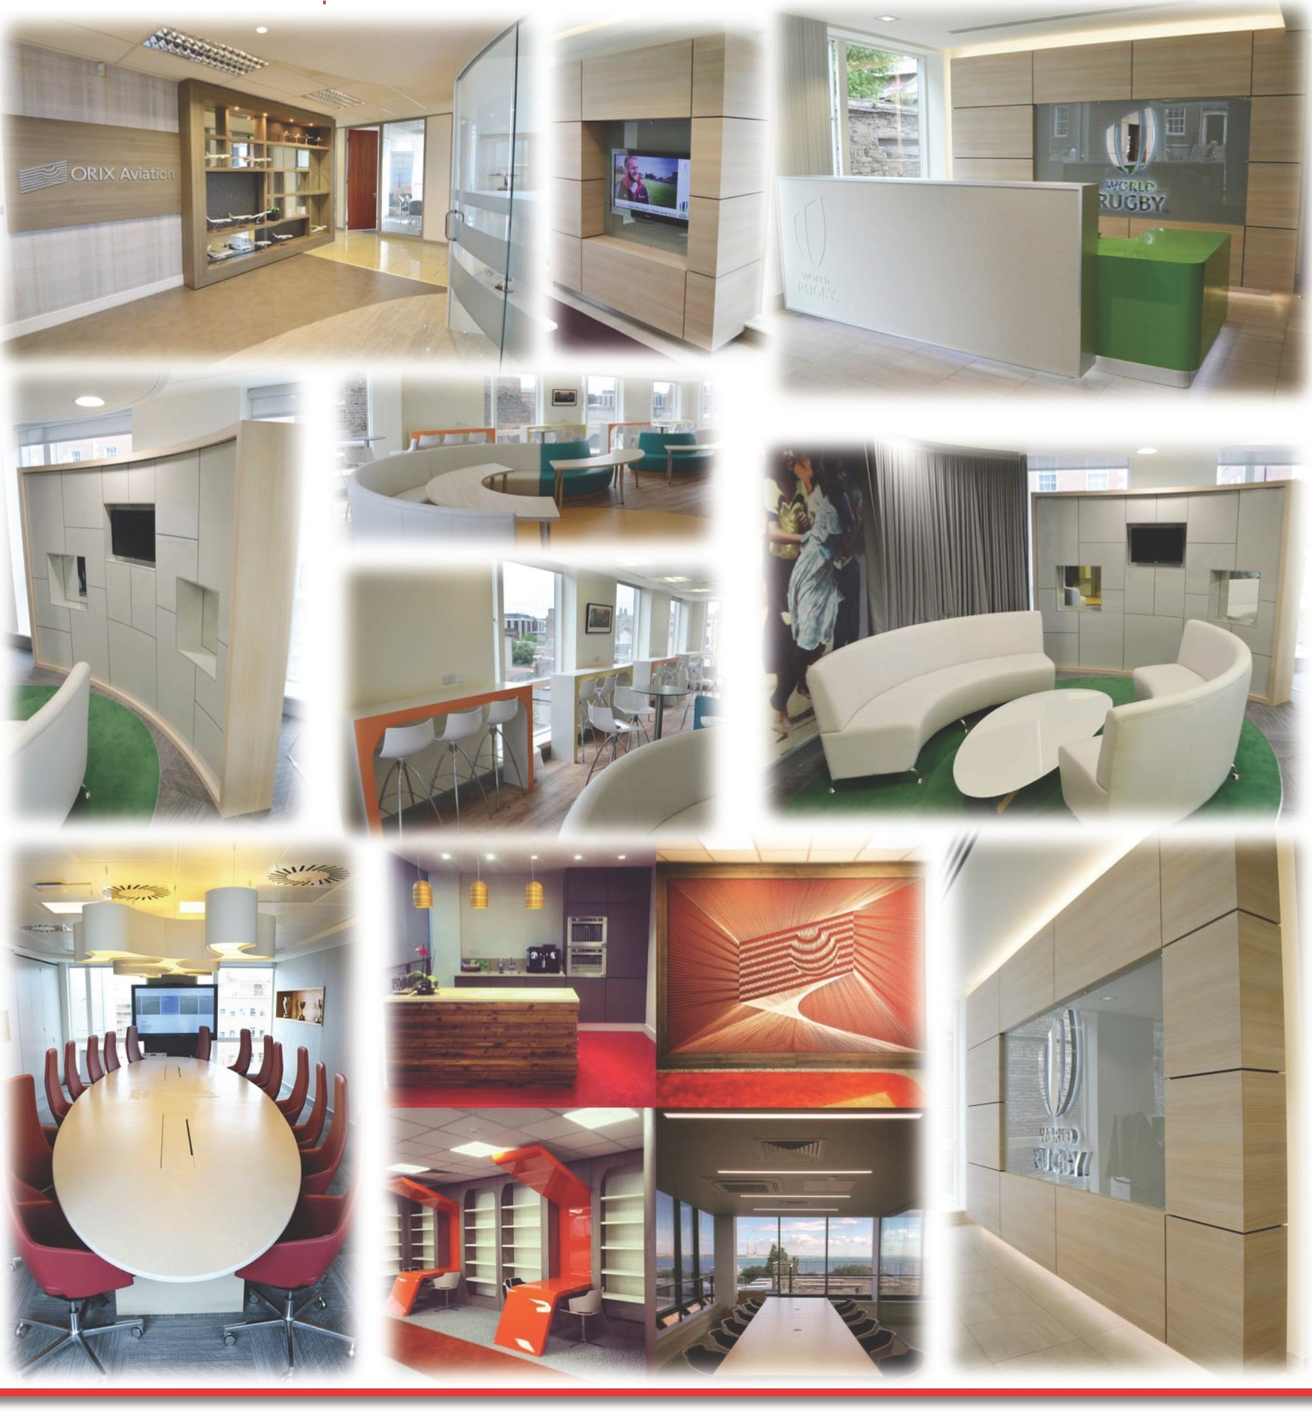elite

Recent Projects

Elite Fit Out Limited
Unit B17 Valley Business Centre
Newtownabbey
BT36 7LS

02890 864 133 info@eliteni.com

www.eliteni.com

